**Biology STAAR Review Stations**

**Day 4**

**Category # 2 Mechanisms of Genetics (6.A, 6.B, 6.C, 6.D)**

6.A identify components of DNA, and describe how information for specifying the traits of an organism is carried in the DNA

6.B recognize that components that make up the genetic code are common to all organisms

6.C explain the purpose and process of transcription and translation using models of DNA and RNA

6.D recognize that gene expression is a regulated process

**6.A, 6.B, 6.C, 6.D Pre-Test Score________ Focus TEKS_____________________**

|  |  |  |  |  |
| --- | --- | --- | --- | --- |
|  | **6.A** | **6.B** | **6.C** | **6.D** |
| **Interactive Quizzes** | **What is DNA? Tutorial**  <http://learn.genetics.utah.edu/content/molecules/dna/> | **DNA Quiz**  <http://www.softschools.com/quizzes/biology/dna/quiz2295.html> | **Transcription and Translation Quiz**  <http://www.proprofs.com/quiz-school/story.php?title=biologytranscription-translation> | **Gene Expression and Regulation Quiz**  <http://quizlet.com/15282489/test> |
| **Graphic Organizers** | **DNA Graphic Organizer**  <http://mvhs1.mbhs.edu/edgrid/dna/dnamod1eng.pdf> | | **DNA/RNA Graphic Organizer**  See handout | **Gene Expression and Regulation Graphic Organizer**  [**http://tinyurl.com/lghzjs3**](http://tinyurl.com/lghzjs3) |
| **Virtual Labs** | **Build a DNA Molecule**  [**http://learn.genetics.utah.edu/content/molecules/builddna/**](http://learn.genetics.utah.edu/content/molecules/builddna/) | **Transcribe and Translate a Gene**  [**http://learn.genetics.utah.edu/content/molecules/transcribe/**](http://learn.genetics.utah.edu/content/molecules/transcribe/) | **What is the role of DNA and RNA in protein synthesis?**  <http://www.glencoe.com/sites/common_assets/science/virtual_labs/LS04/LS04.html> | |
| **Vocabulary** | **DNA Flashcards**  <http://quizlet.com/3071891/biology-dna-flashcards-flash-cards/> | **Genetic Code Flashcards**  <http://quizlet.com/10872685/biology-dna-as-the-genetic-code-flash-cards/> | **Transcription/Translation Flashcards**  [**http://quizlet.com/750710/transcription-and-translation-flash-cards/**](http://quizlet.com/750710/transcription-and-translation-flash-cards/) | **Gene Expression Flashcards**  [**http://tinyurl.com/lghzjs3**](http://tinyurl.com/lghzjs3) |
| **Video Clips** | **The Structure and Function of DNA**  <http://www.youtube.com/watch?v=_POdWsii7AI> | **One Wrong Letter**  <http://www.pbs.org/wgbh/nova/genome/media/2809_q056_03.html> | **Transcription and Translation**  <http://www.youtube.com/watch?v=41_Ne5mS2ls> | **Gene Expression Video**  <http://www.ck12.org/biology/Gene-Expression/lecture/user:13IntW/Gene-Expression/r1/>  **Control of Gene Expression in Eukaryotes**  <http://highered.mcgraw-hill.com/olc/dl/120080/bio31.swf> |

**Critical Thinking Questions**

1. Describe the composition of DNA.

2. How is genetic information carried by DNA?

3. Discuss differences between DNA and RNA.

4. Describe nucleotide composition.

5. What is a genome?

6. Why must transcription and translation occur?

7. How does DNA instruct the body to make protein?

**6.C DNA/RNA Graphic Organizer**

|  |  |  |
| --- | --- | --- |
|  | **DNA** | **RNA** |
| **Draw the molecule** |  |  |
| **Double or single stranded?** |  |  |
| **Type of sugar** |  |  |
| **List the nucleotides** |  |  |
| **Where is it found?** |  |  |

**Word bank**

Double

Single

Deoxyribose

Ribose

Adenine

Thymine

Uracil

Guanine

Cytosine

Nucleus

Ribosome

Cytoplasm

**Match the appropriate process with the proper description by drawing a line to connect the two.**

Replication DNA🡪RNA (in the nucleus)

Transcription RNA🡪amino acid/protein (in the ribosome)

Translation DNA🡪DNA (in the nucleus)

**Day 4 Review Questions 6.A, 6.B, 6.C, 6.D**

6.A

_____1. Molecules of DNA are constructed from long chains of

a. amino acids

b. fatty acids

c. monosaccharides

d. nucleotides

6.A

_____2. **DNA** is a polymer which is made up of subunits called **nucleotides**. Nucleotides have **three** basic parts. Which of these is ***not*** a nucleotide component?



a. deoxyribose sugar

b. phosphate group

c. ribose sugar

d. nitrogenous base

6.A.

_____3. A nitrogenous base is an important component of the **nucleotide** making up DNA. Which of the following **correctly** lists the **four possible nitrogenous** **bases** in **DNA**?

a. adenine, guanine, cytosine, uracil

b. leucine, proline, tyrosine, phenylalanine

c. glutamine, proline, tyrosine, phenylalanine

d. adenine, guanine, cytosine, thymine

6.A

_____4. Which of the following **correctly** shows a **complementary base pair** of **nitrogenous bases** in a **DNA** molecule?

a. adenine- guanine

b. guanine- cytosine

c. cytosine- adenine

d. guanine- thymine

6.B

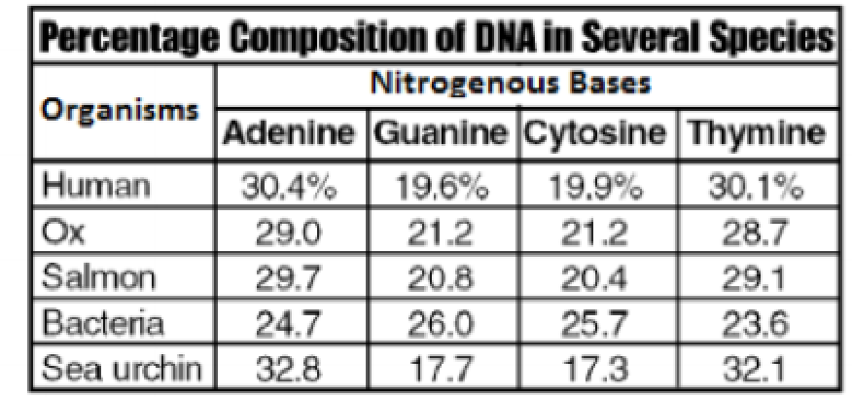

_____5. According to the table:

1. all organisms have common nitrogenous bases
2. humans have a unique set of nitrogen bases similar to no other organisms
3. salmon and humans only have adenine in common
4. bacteria and oxen only have guanine in common

6.B

_____6. Which genetic code component differs between DNA and RNA?

a. the presence of adenine in the codons

b. the presence of uracil in the codons

c. the presence of amino acids in the codons

d. the presence of guanine in the codons

6.B

_____7. The genetic code is common for all organisms. If a gene segment contains 27 nucleotides, none of which are start or stop codons, how many amino acids does this segment code for?

1. 27 amino acids
2. 3 amino acids
3. 9 amino acids
4. 54 amino acids

6.B

_____8. The genetic code is almost universal. With few exceptions, the same codons code for the same amino acids in all organisms. What does this suggest about the genetic code?

1. all life forms can reproduce with one another
2. all life forms have a common evolutionary ancestor
3. all life forms have the same number of chromosomes
4. all life forms developed during the same time in history

6.C

_____9. During transcription,

a proteins are synthesized

b. DNA is replicated

c. RNA is produced.

d. translation occurs

6.C

_____10. In order for translation to occur, mRNA must migrate to the

a. ribosomes

b. lac operon

c. RNA polymerase

d. enhancer

6.C

_____11. RNA molecules use instruction from DNA to assemble proteins. There are three types of RNA molecules: mRNA, rRNA and tRNA. What specific **function** does **mRNA** perform in the process of **making proteins**?

a. It brings instructions from DNA in the cell nucleus to the cytoplasm.

b. It clamps onto messenger RNA and uses its information to assemble amino acids.

c. It transports amino acids to the ribosomes to be assembled into proteins.

d. It creates another molecule of DNA through replication.

6.C

_____12. **Translation** is crucial to the **process of making proteins**. Which statement ***best*** describes what **takes place** during **translation**?

a. An RNA copy of a DNA strand is made.

b. Information in mRNA is converted into a sequence of amino acids in a protein.

c. A copy of chromosomal DNA is created.

d. Instructions from DNA in the nucleus are brought to the cytoplasm.

6.D

_____13. A girl inherits genes from both parents for tallness, but her growth is limited due to a lack of proper nutrition. This is an example of ------.

1. expression of a hidden trait
2. an inherited disorder
3. a characteristic controlled by more than one pair of genes
4. environmental influence on gene expression and regulation

6.D

_____14. The control of gene expression is more complex in multicellular eukaryotes than in prokaryotes because in a multicellular eukaryote, different cells are specialized for different functions.

1. true
2. false

6.D

_____15. Gene expression in animals is regulated primarily by _____.

a. controlling the translation of mRNA into protein  
b. controlling the transcription of genes into mRNA

c. manipulating the tRNA

d. managing the operons

6.D

_____16. Which of the following statements is NOT true about the differences between liver cells and kidney cells in the same organism?

**a.** They contain the same genes, but express them differently.   
 **b.** They contain different genes.

**Day Four Review Questions (6.A, 6.B, 6.C, 6.D)**

**Answer Sheet**

**_____1.**

**_____2.**

**_____3.**

**_____4.**

**6.A Score__________/4**

**_____5.**

**_____6.**

**_____7.**

**_____8.**

**6.B Score__________/4**

**_____9.**

**_____10.**

**_____11.**

**_____12.**

**6.C Score__________/4**

**_____13.**

**_____14.**

**_____15.**

**_____16.**

**6.D Score__________/4**

**Day Four Review Questions (6.A, 6.B, 6.C, 6.D)**

**Key**

**__A__1.**

**__C__2.**

**__D__3.**

**__B__4.**

**__A__5.**

**__B__6.**

**__C__7.**

**__B__8.**

**__B__9.**

**__D__10.**

**__A__11.**

**_ B__12.**

**__D___13.**

**__A___14.**

**__B__ 15.**

**__B___16.**